**Power Apps portals Studio**

## Open portals Studio

To open Power Apps portals Studio:

1. Go to [Power Apps](https://make.powerapps.com/).
2. Select **Apps** from the left pane.

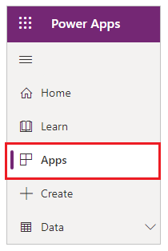

1. Select your portal.
2. Select **Edit**.

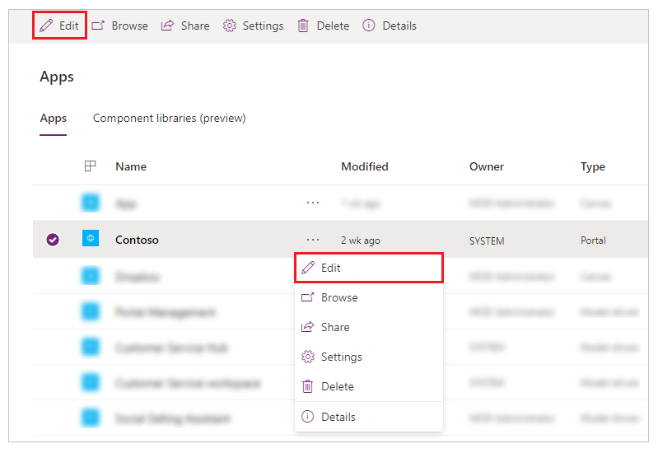

## Understand portals Studio

The anatomy of Power Apps portals Studio is as follows:

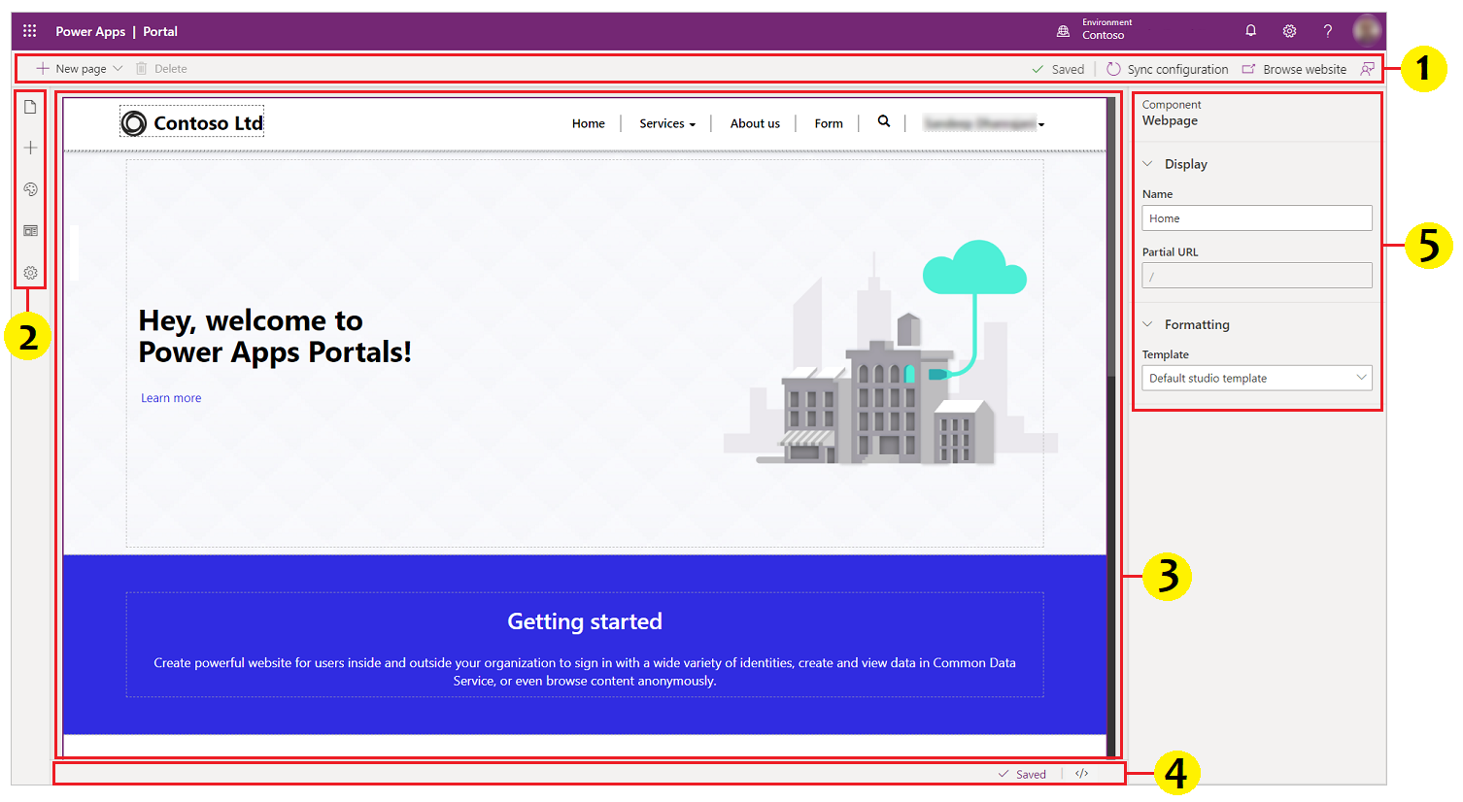

| **UNDERSTAND PORTALS STUDIO** | | |
| --- | --- | --- |
| **Annotation** | **Name** | **Description** |
| 1 | Command bar | Allows you to:   * Create a webpage. * Delete a component. * Sync Configuration - synchronizes the latest portal configuration changes in Microsoft Dataverse database with your current Studio session. For example, use Sync Configuration to reflect the changes in Studio when using the Portal Management app to change the configuration of pages, forms or any other objects. * Browse website - clears the portal cache and opens the current portal page. |
| 2 | Toolbelt | Allows you to:   * View and manage webpages * Add components * Edit templates |
| 3 | Canvas | Contains components that build a webpage. |
| 4 | Footer | Displays autosave status and allows you to open-source code editor. |
| 5 | Properties pane | Displays properties of webpage and selected components and lets you edit them as required. |